Appendix G: Subgroup analysis charts
Methodology and interpretation

Results for each demographic subgroup were generated as estimated marginal means using a mixed effects model allowing for a binary outcome, featuring a random trust effect (an effect allowing clusters of observations to vary randomly) and fixed effects of measured demographic and care characteristic factors (effects measured at the individual level).

For analyses of single questions, the modelled binary outcome was whether the respondent selected the most positive answer (“top box”) for that question (i.e. selected most positive = 1; did not select the most positive = 0).

The results generated by these analyses can be interpreted as: the average probability that people with this characteristic, controlling for other characteristics in the model, selected the most positive answer for the question.

In this report, subgroup differences are considered reportable where a demographic or care characteristic overall (e.g. age) is significantly associated with experience and where the estimated marginal mean for the specific subgroup (e.g. 16 to 35) is significantly different from the overall mean. For further technical information on the subgroup analysis please see the Quality and Methodology document.

The analysis modelled the responses of different subgroups by age, parity (whether respondents have had a previous baby or not), continuity of care, type of delivery, ethnicity, religion, sexual orientation, long-term health conditions, pregnancy related conditions, gender same as sex assigned at birth, whether English is spoken as a main language and Indices of Multiple Deprivation (IMD) decile.

Graphs

The graphs that follow highlight better than average experiences that are significant in green. Significantly worse than average experiences are highlighted in orange.

Worse than average experience
Average experience
Better than average experience

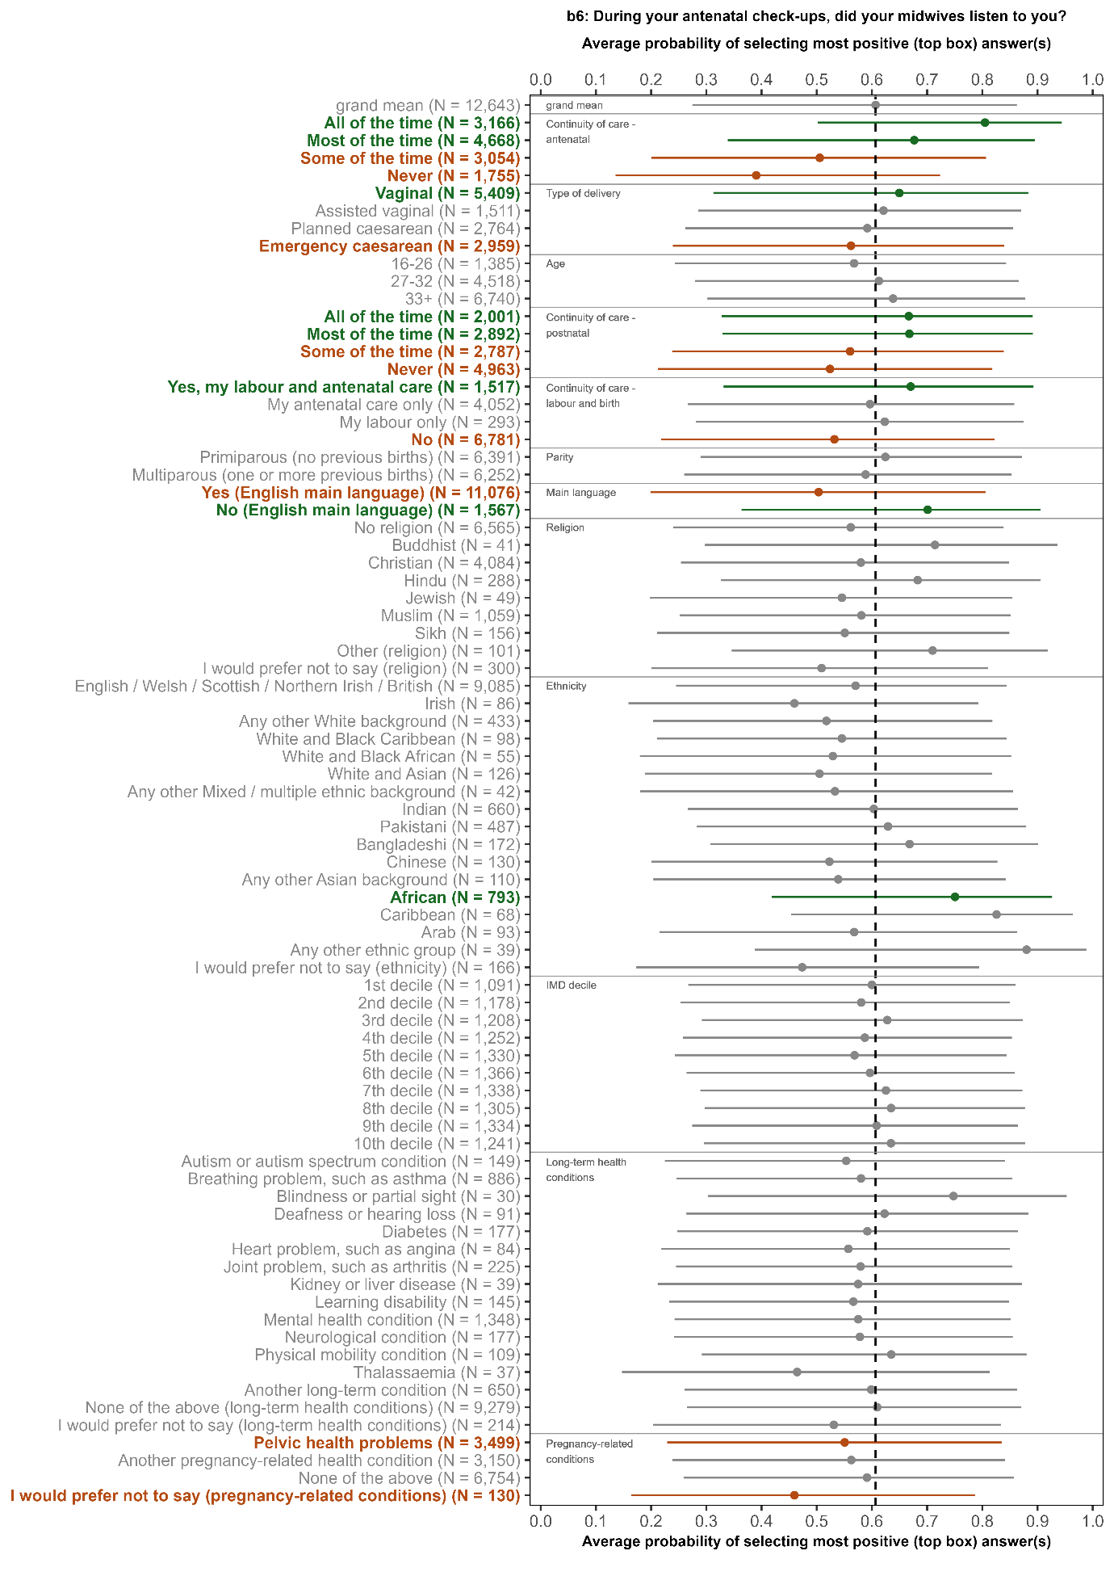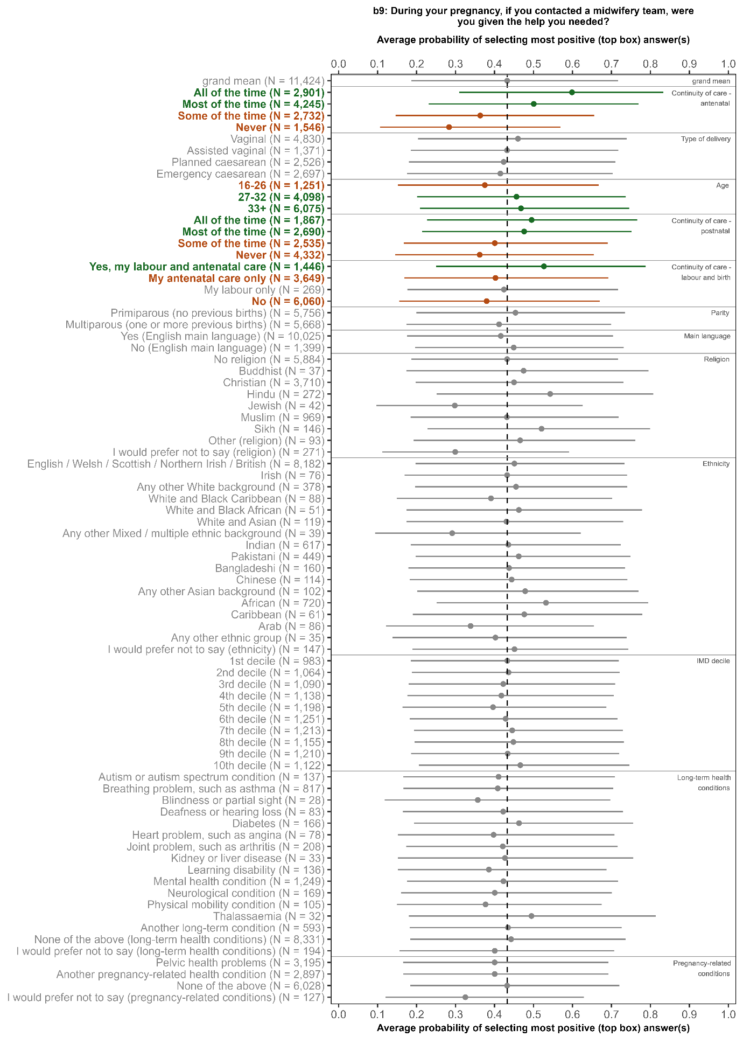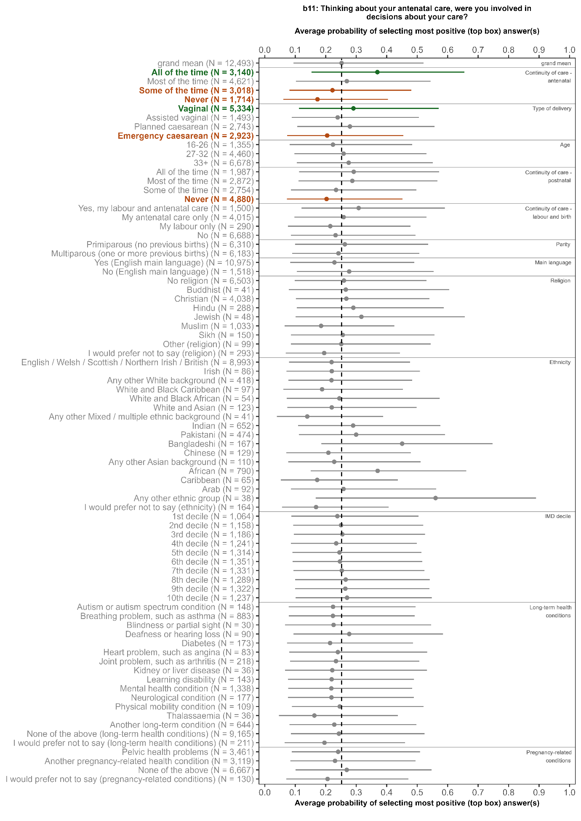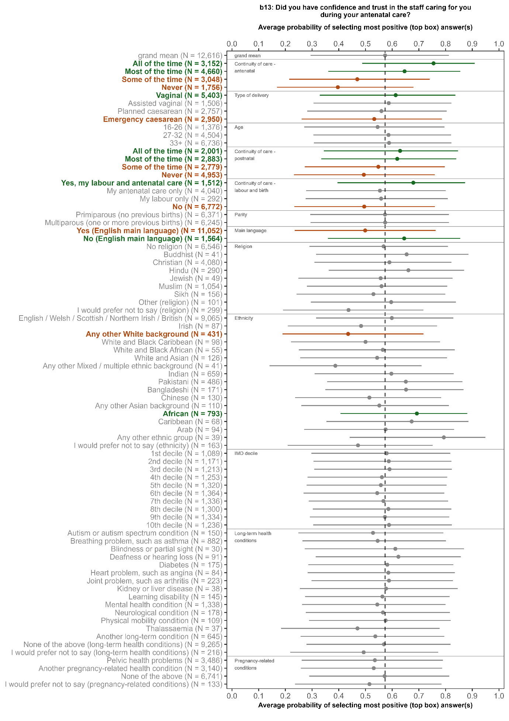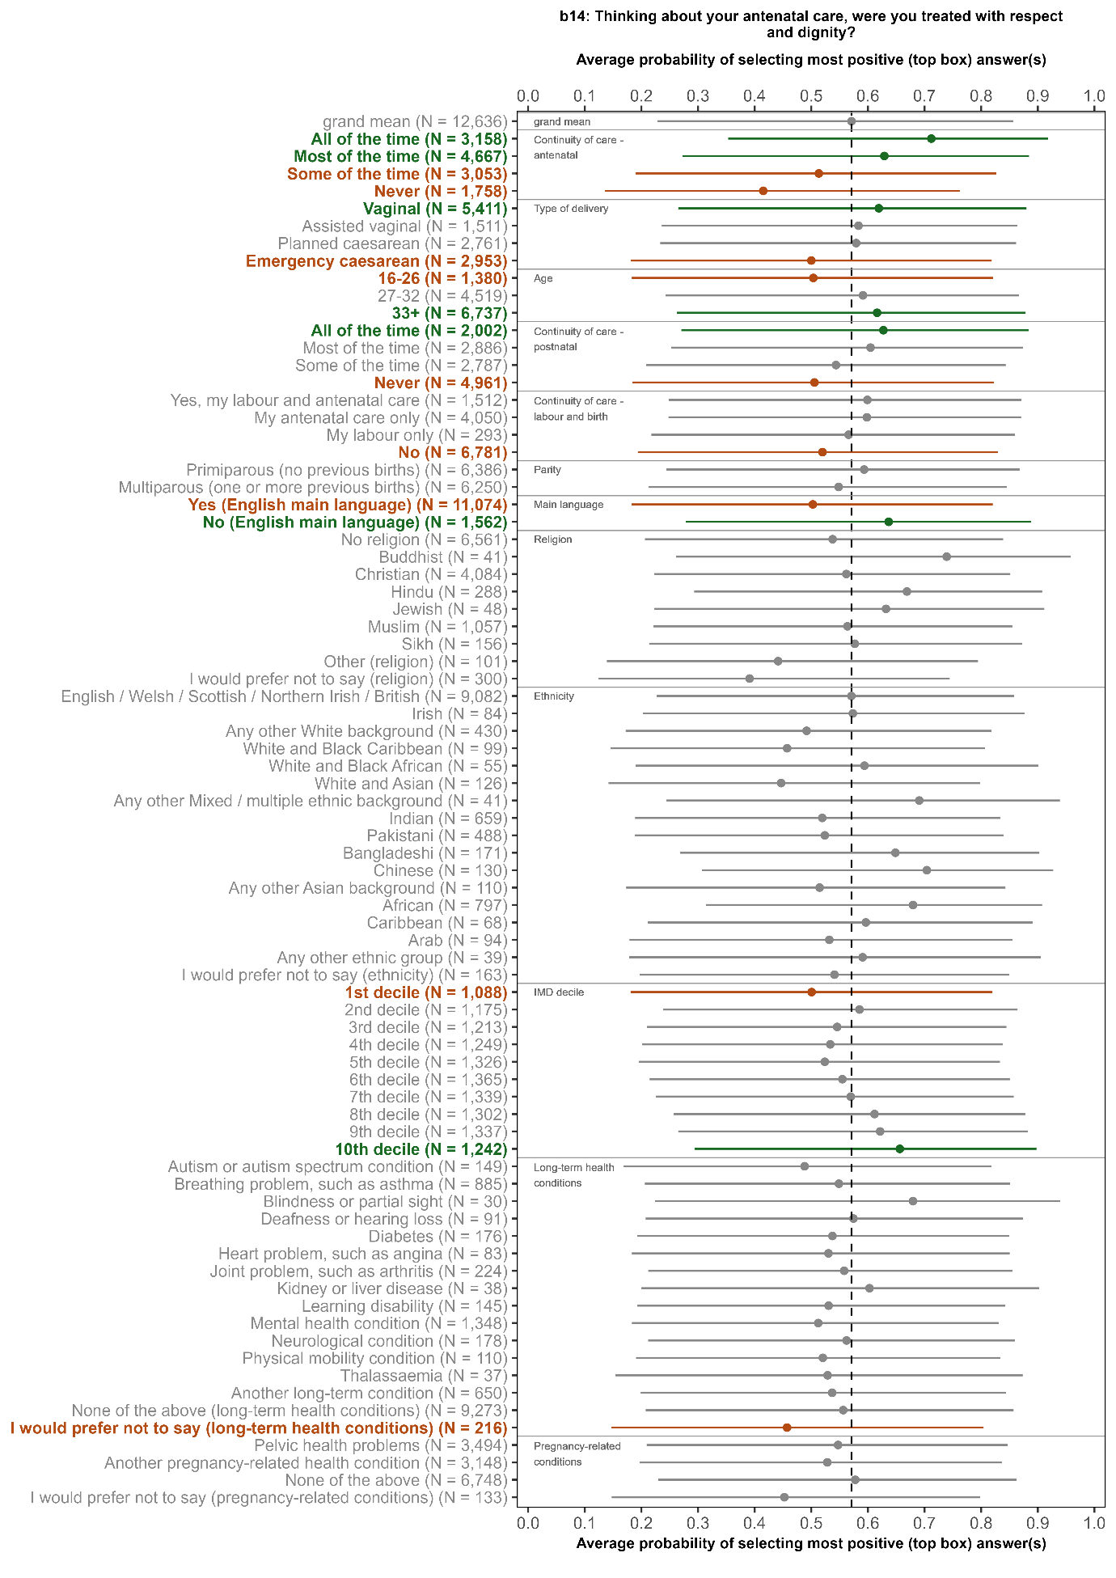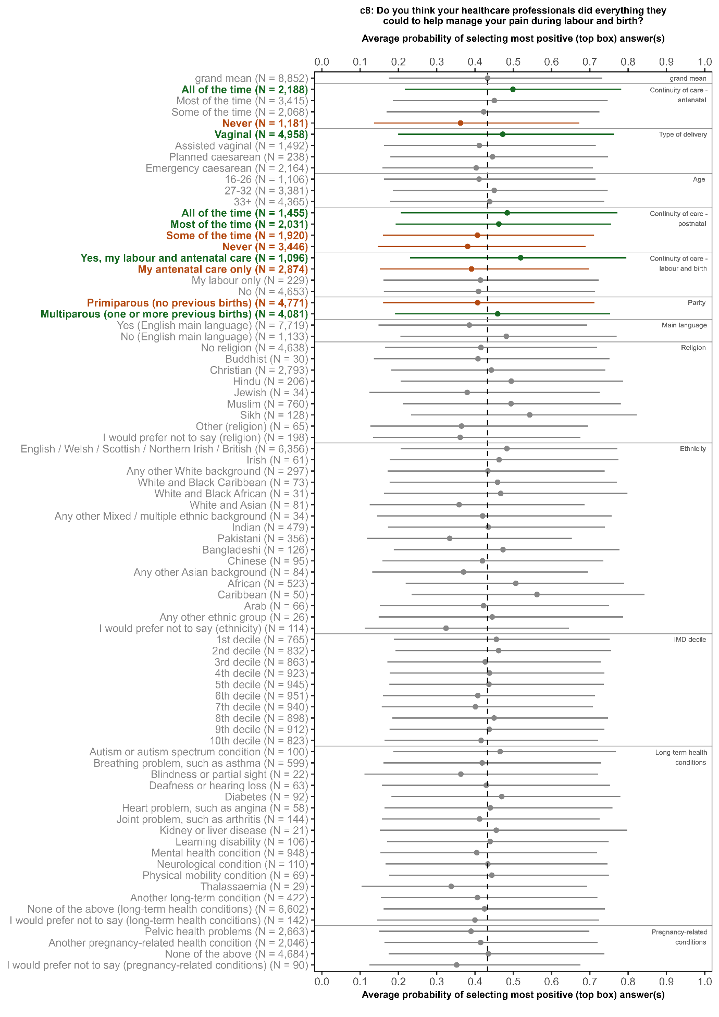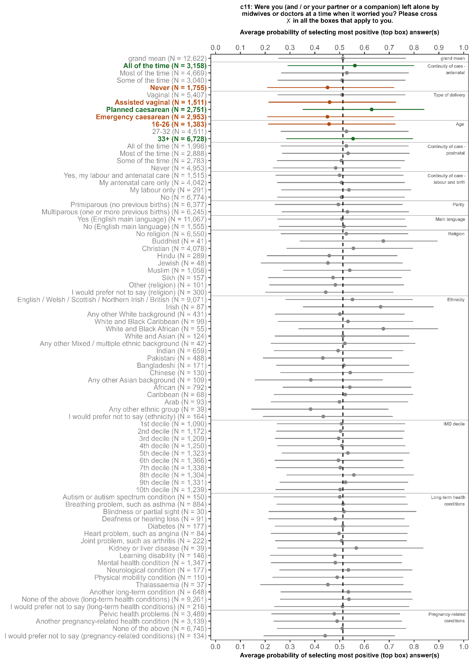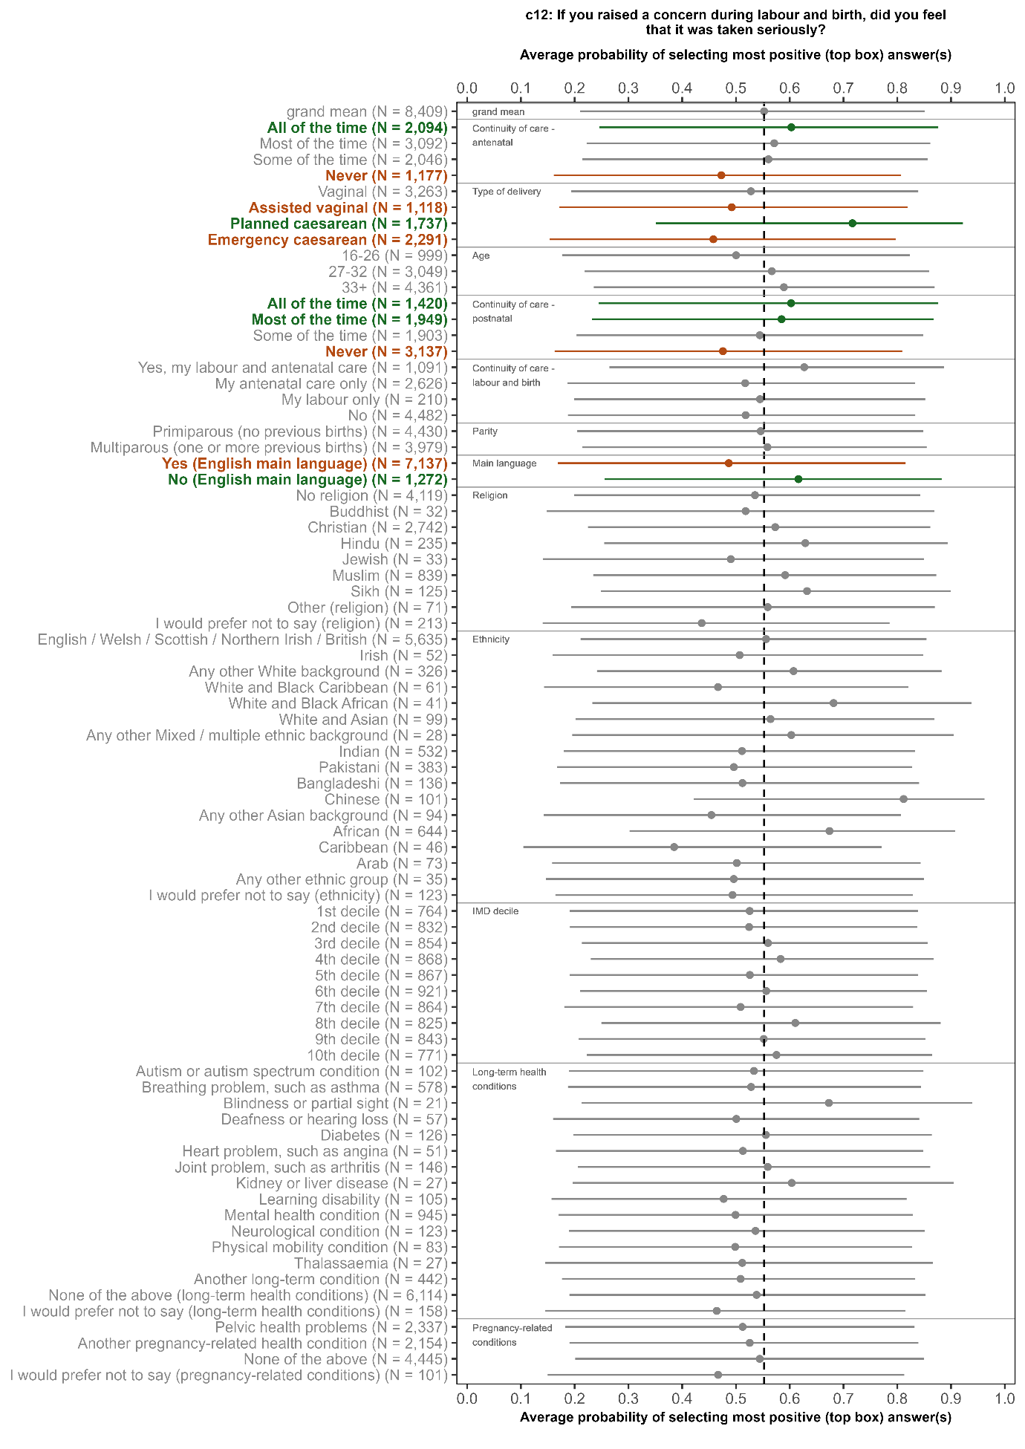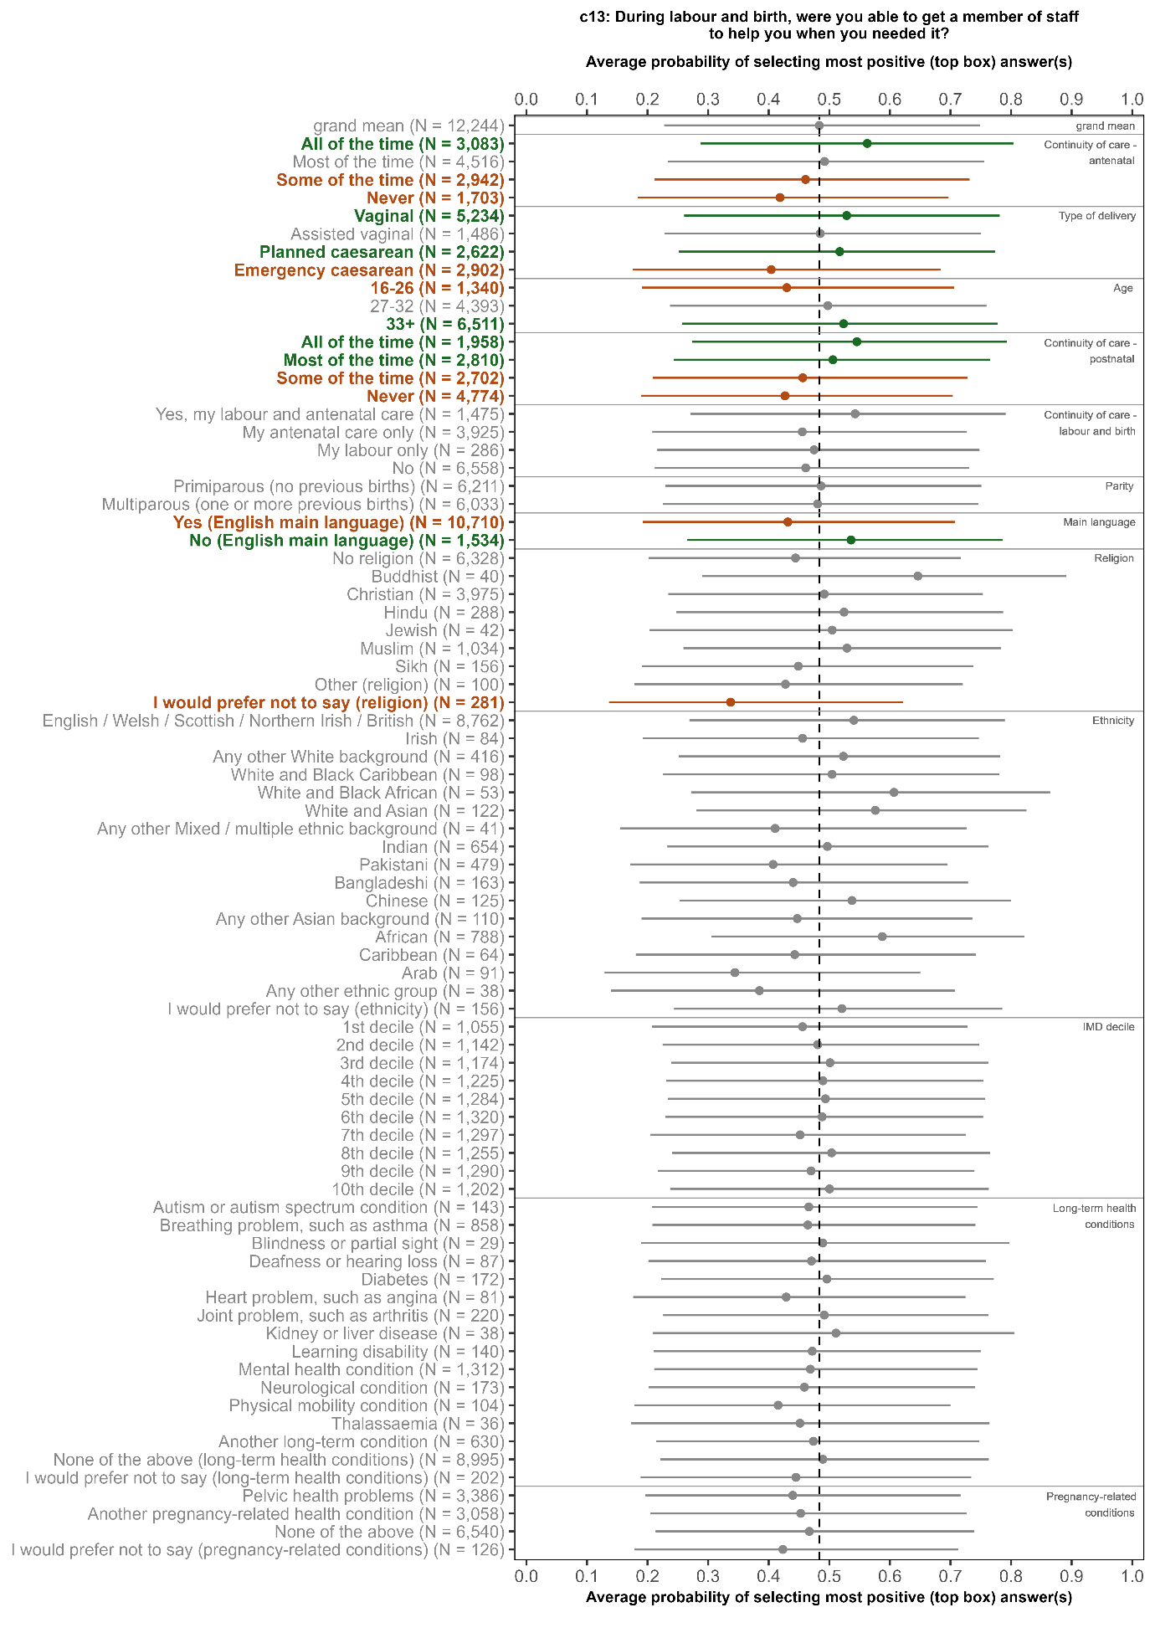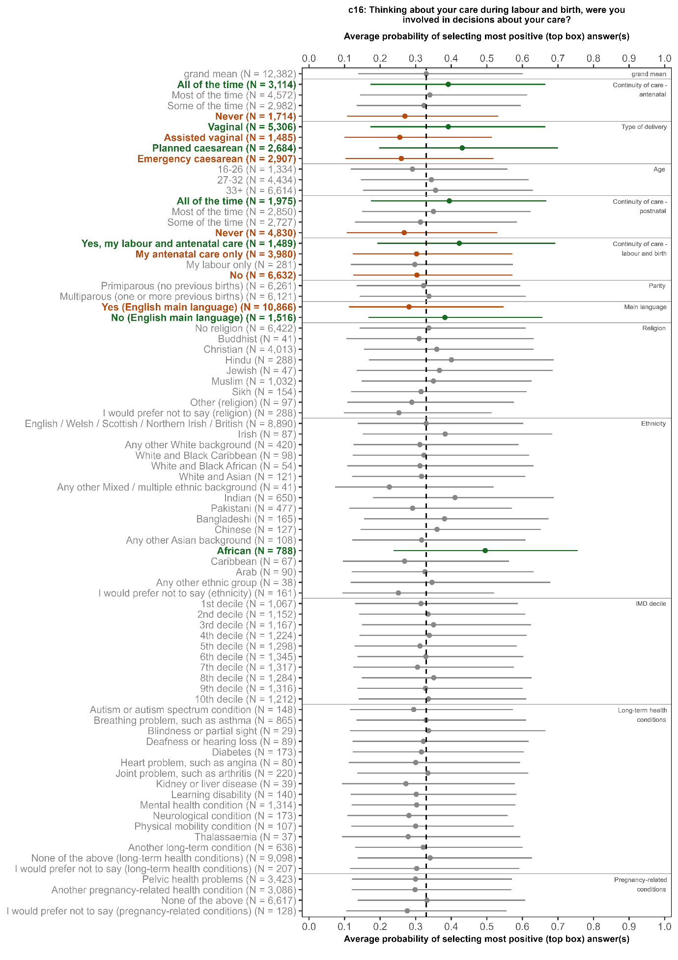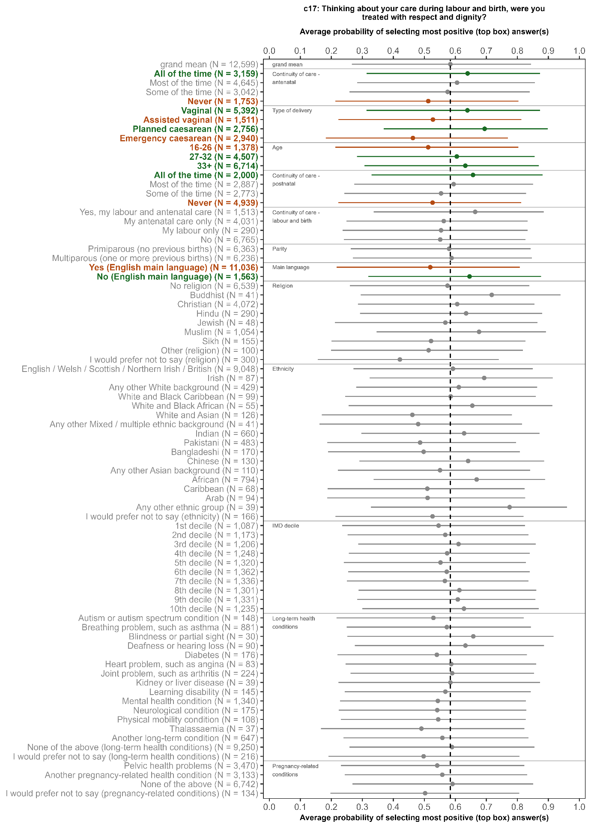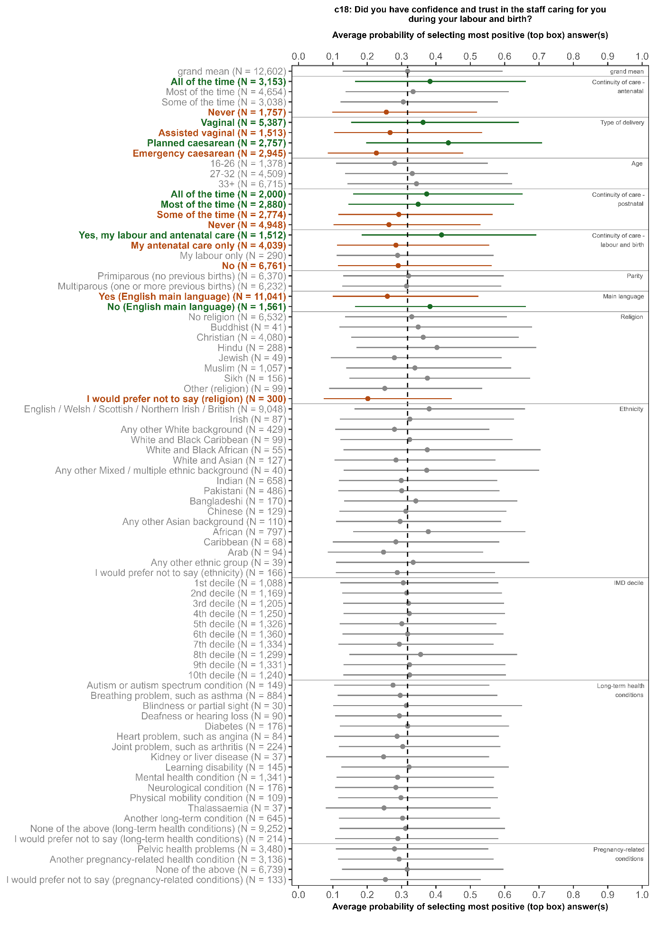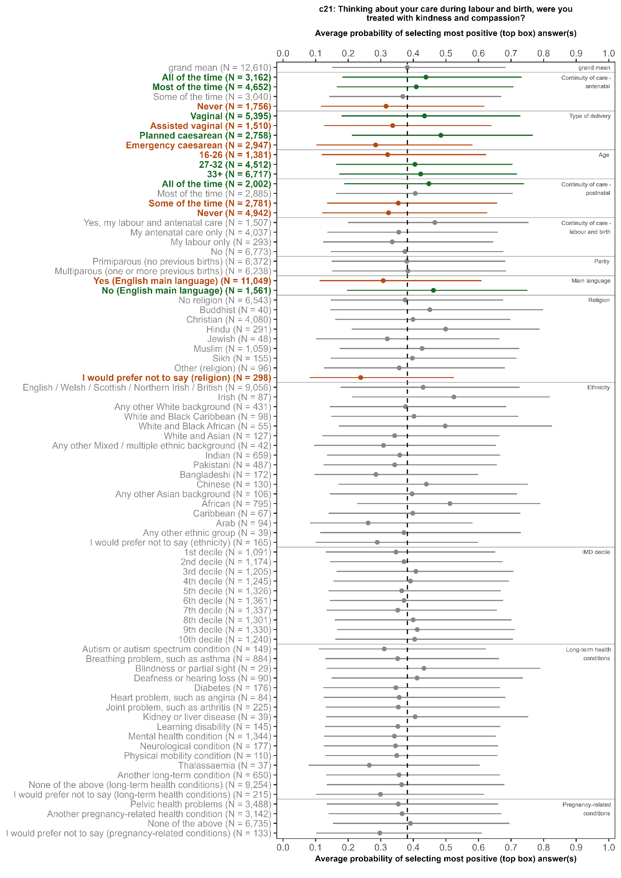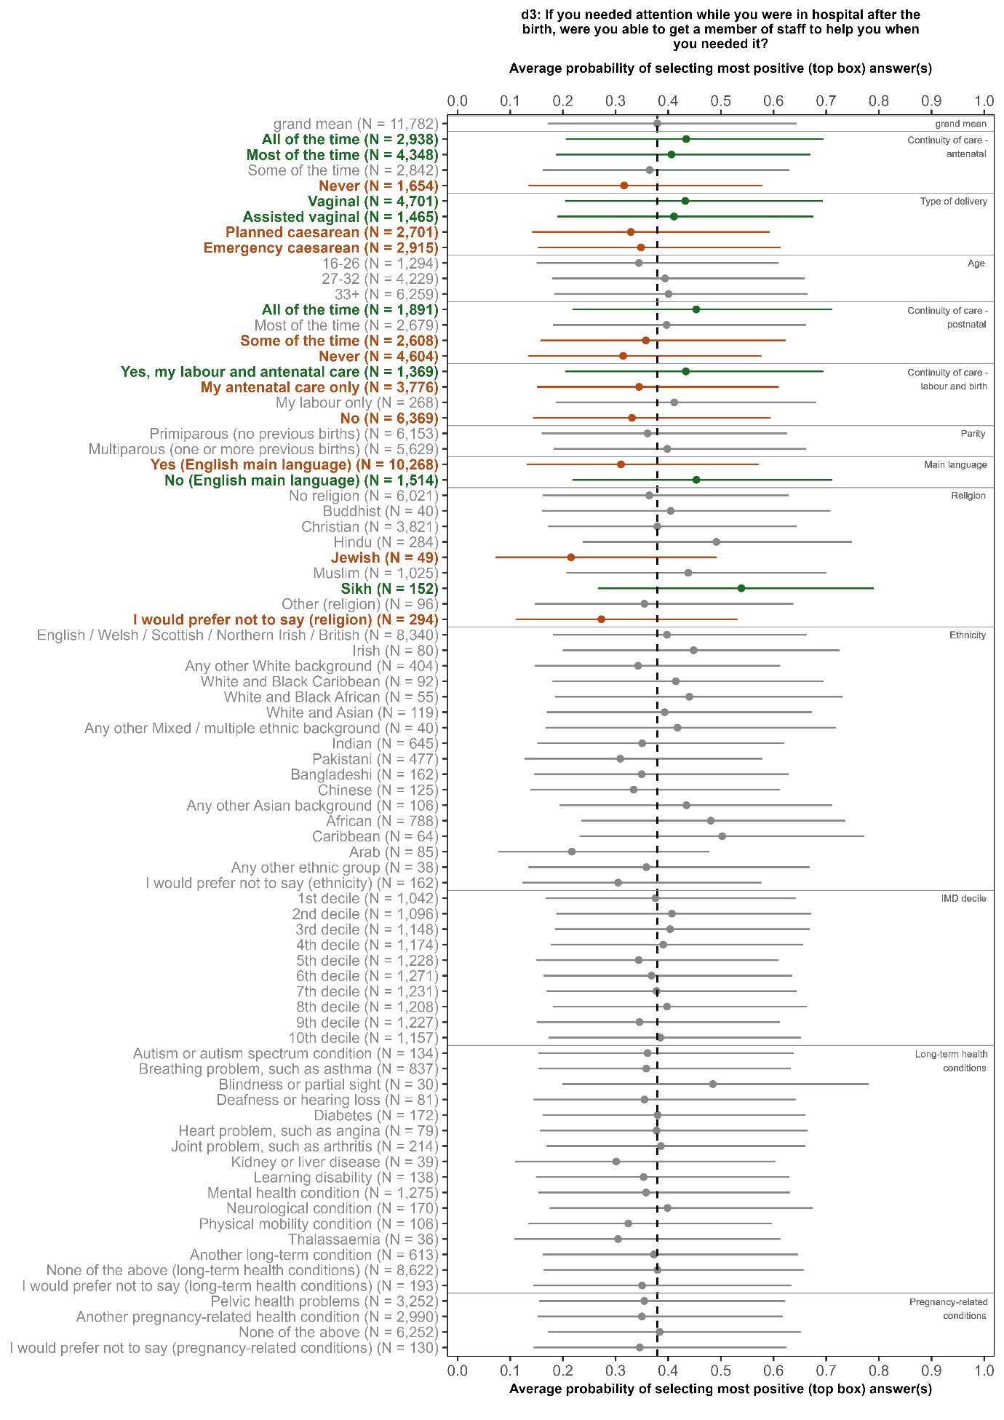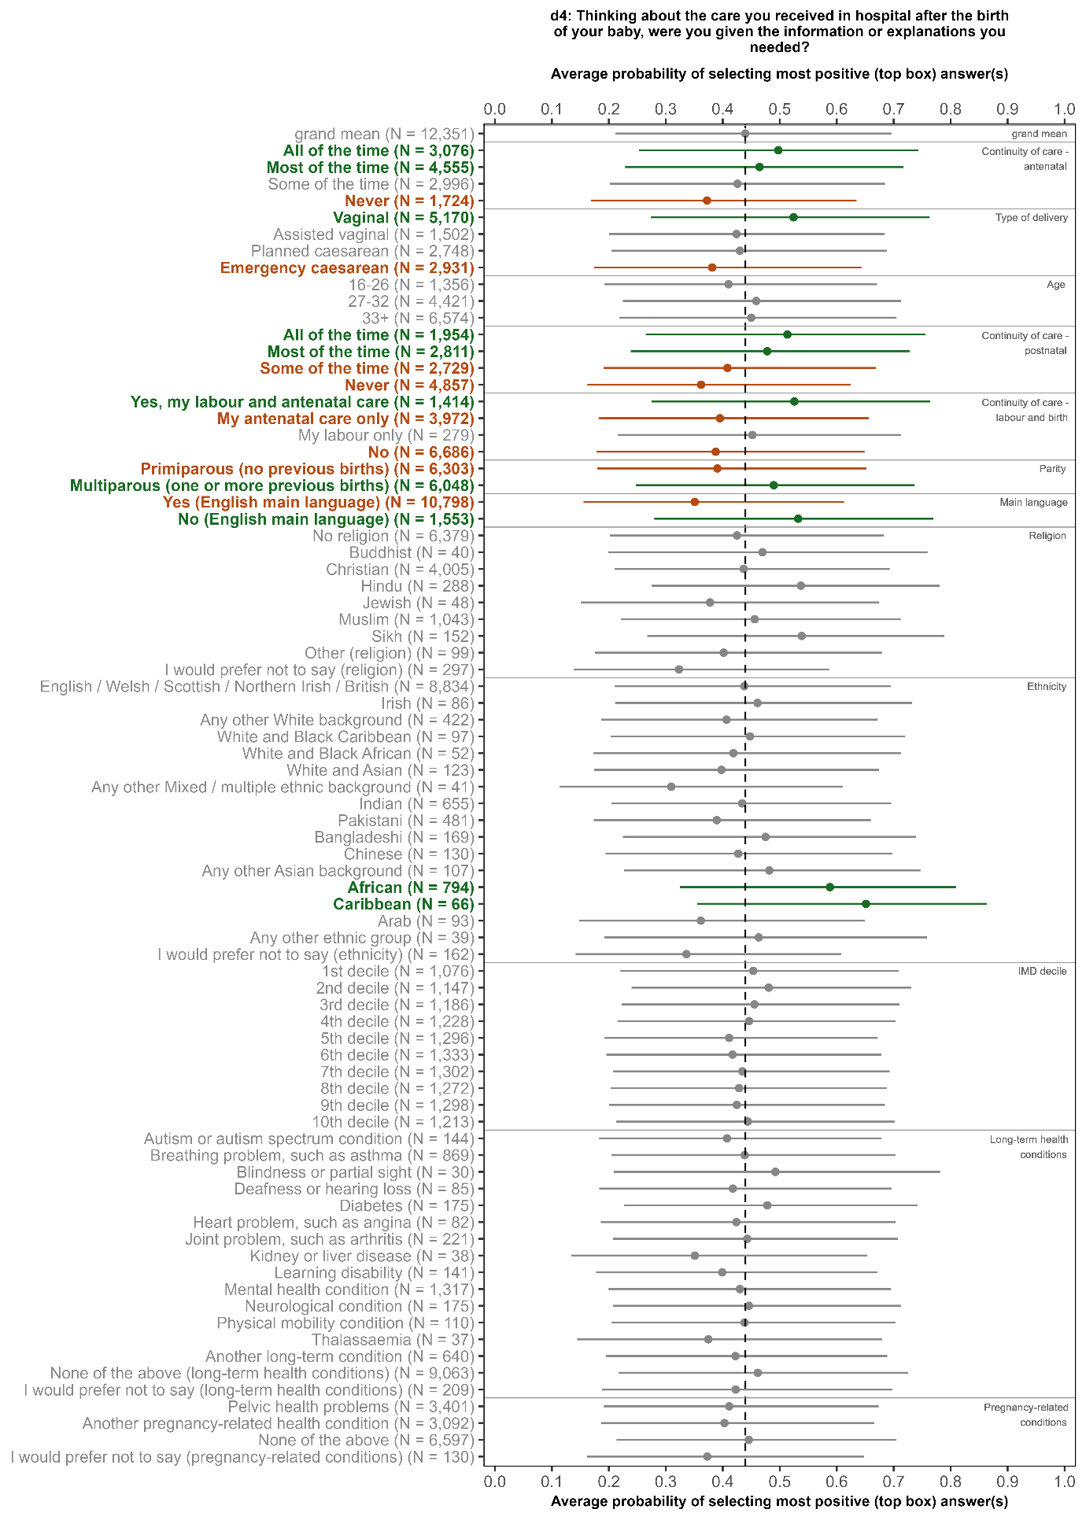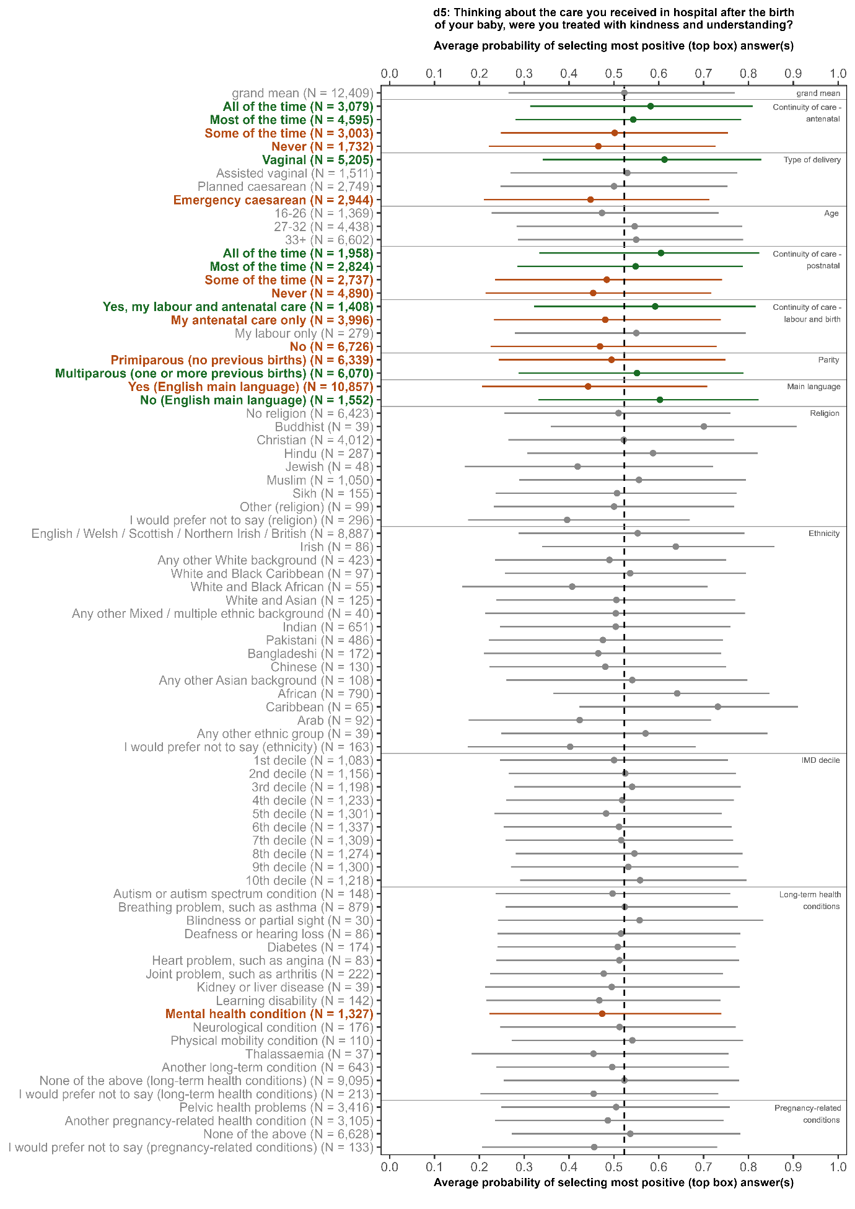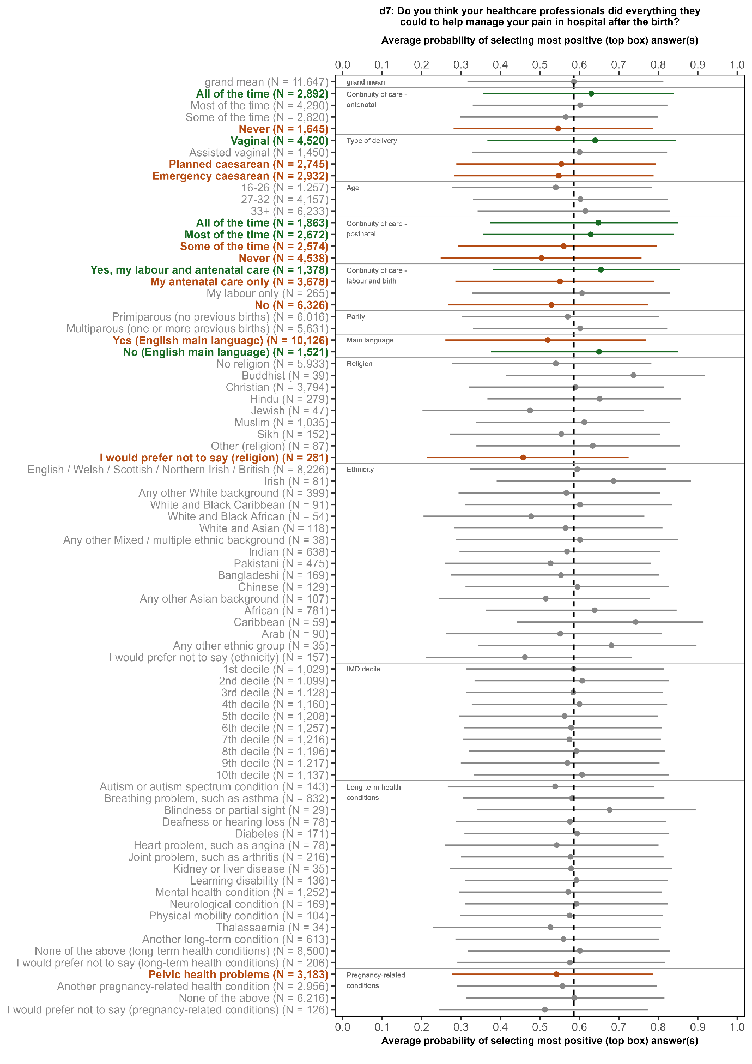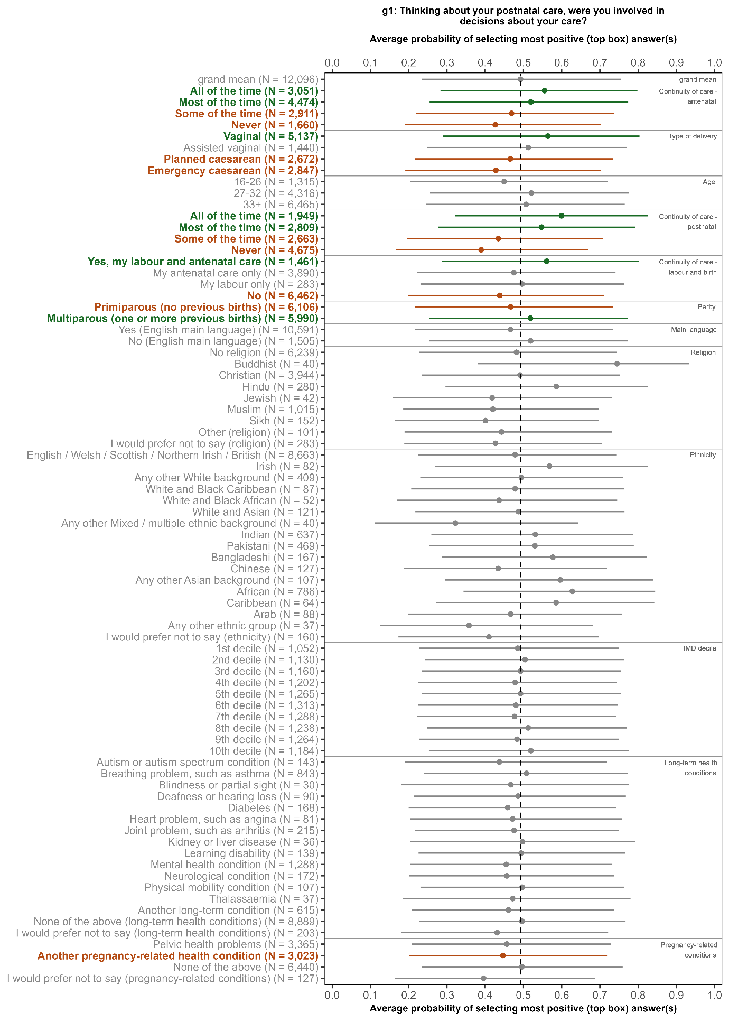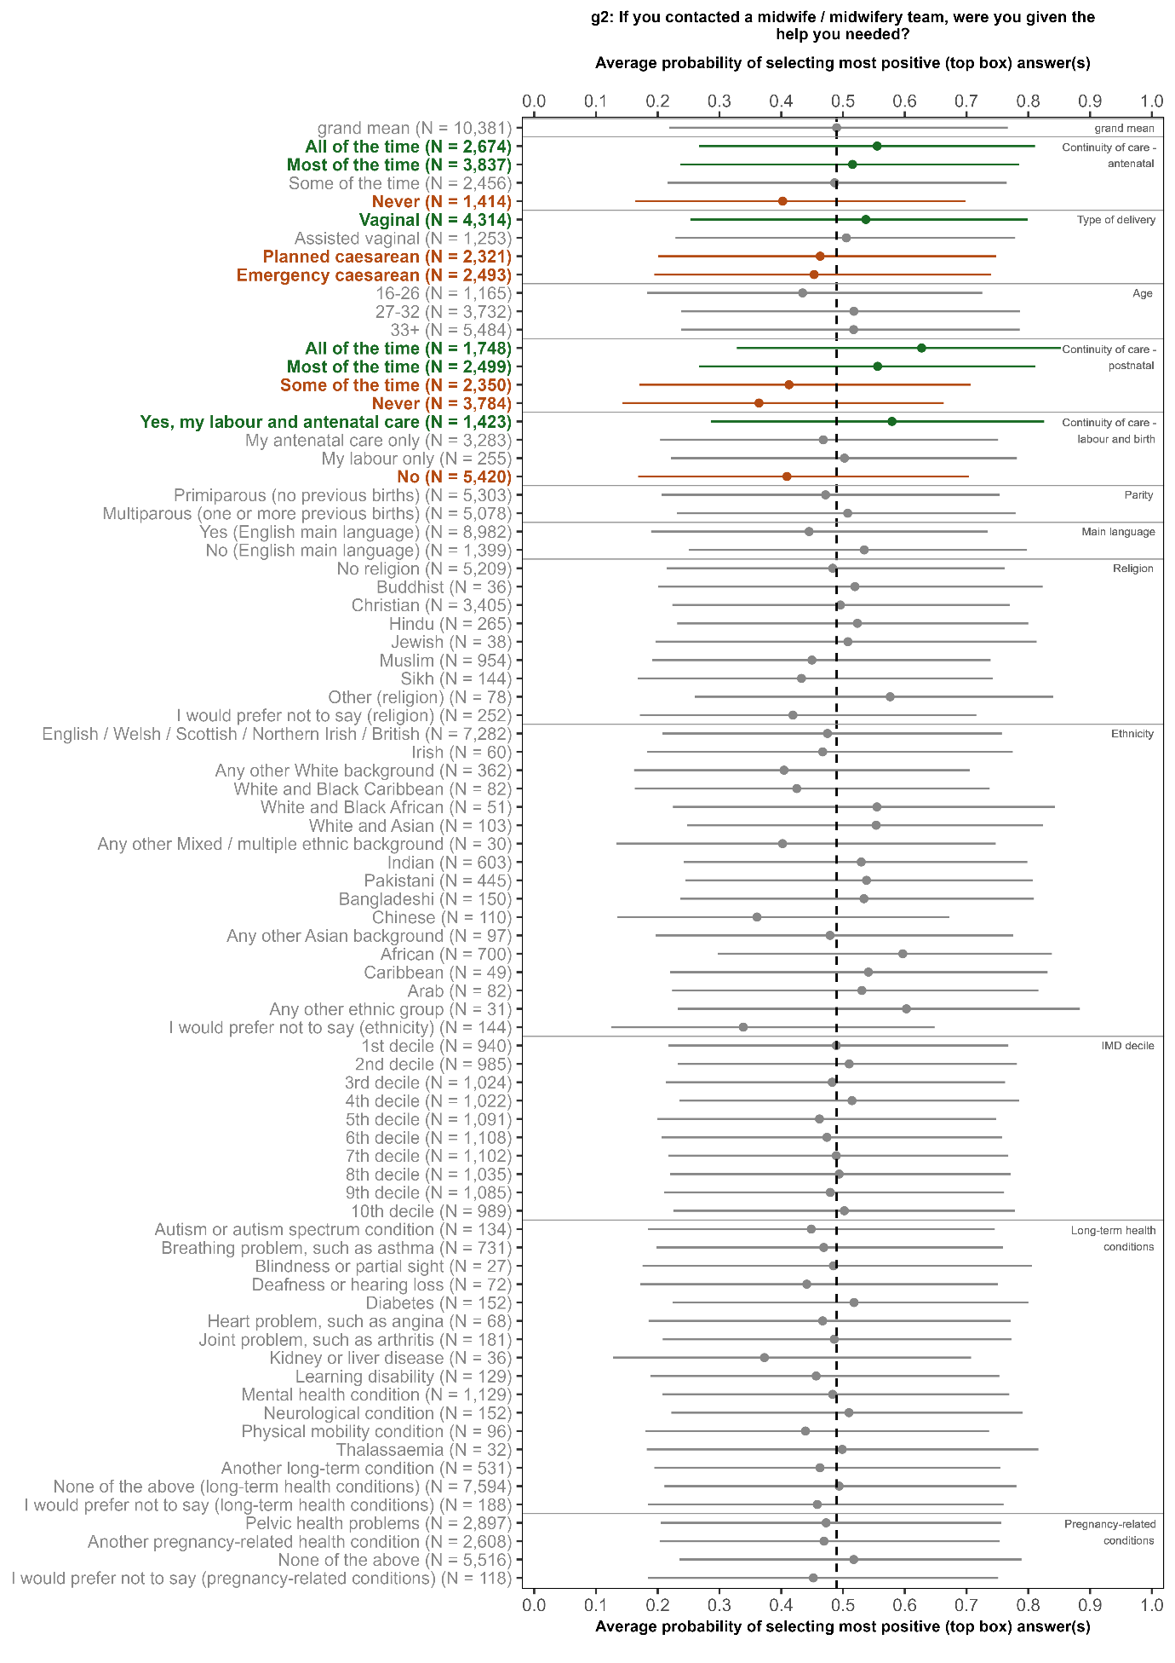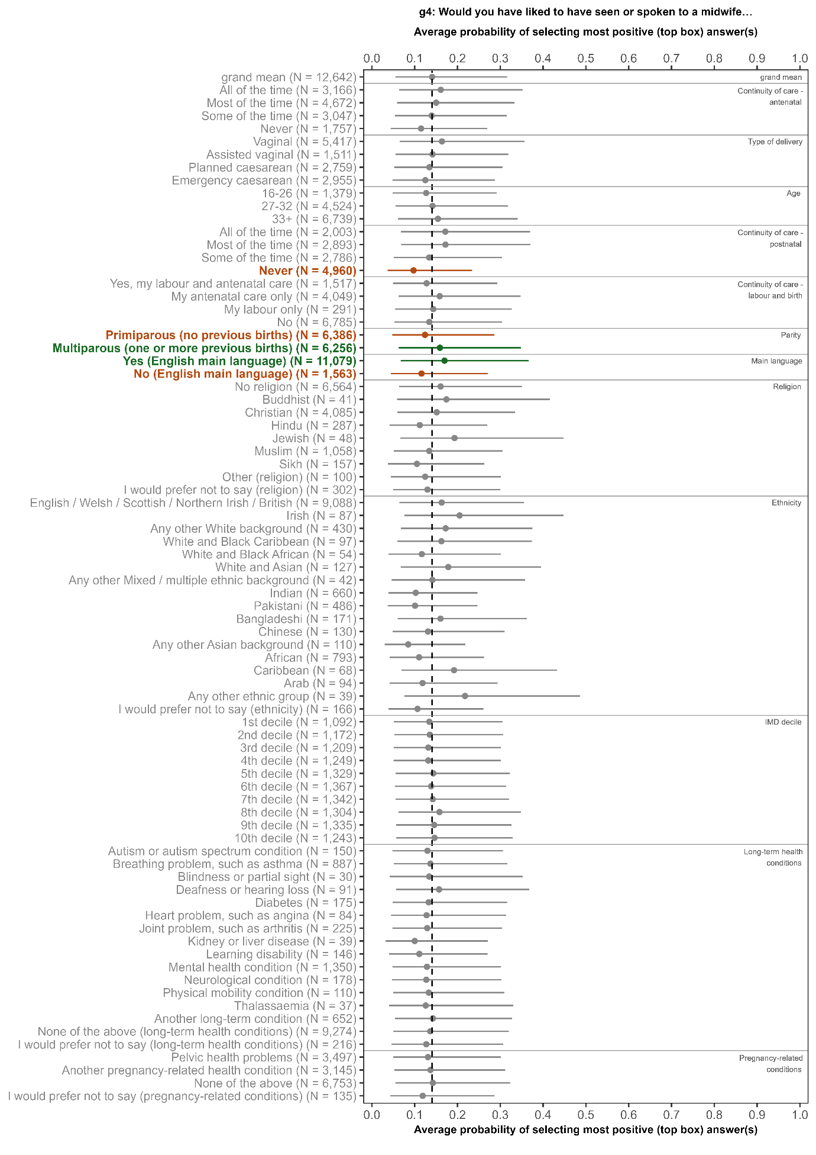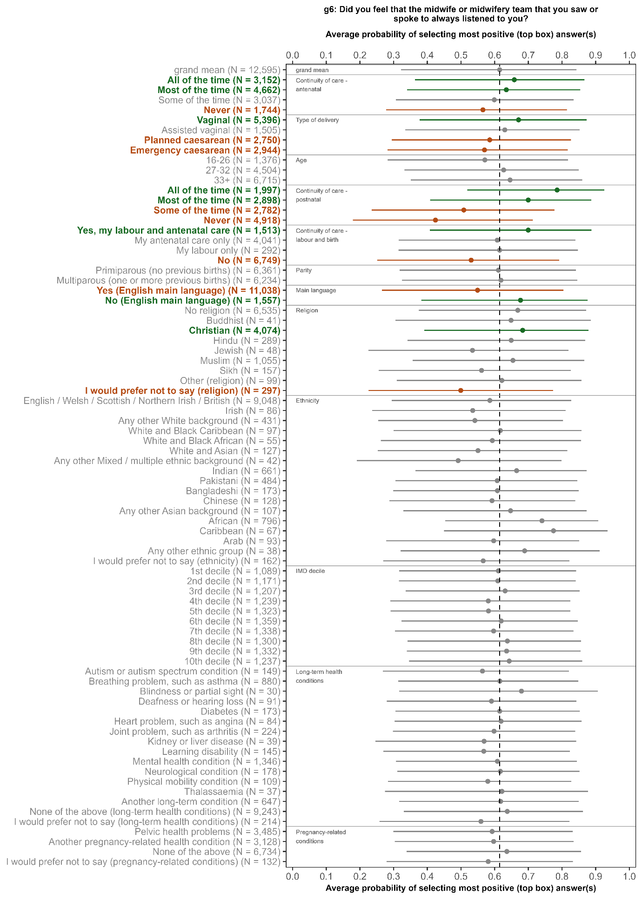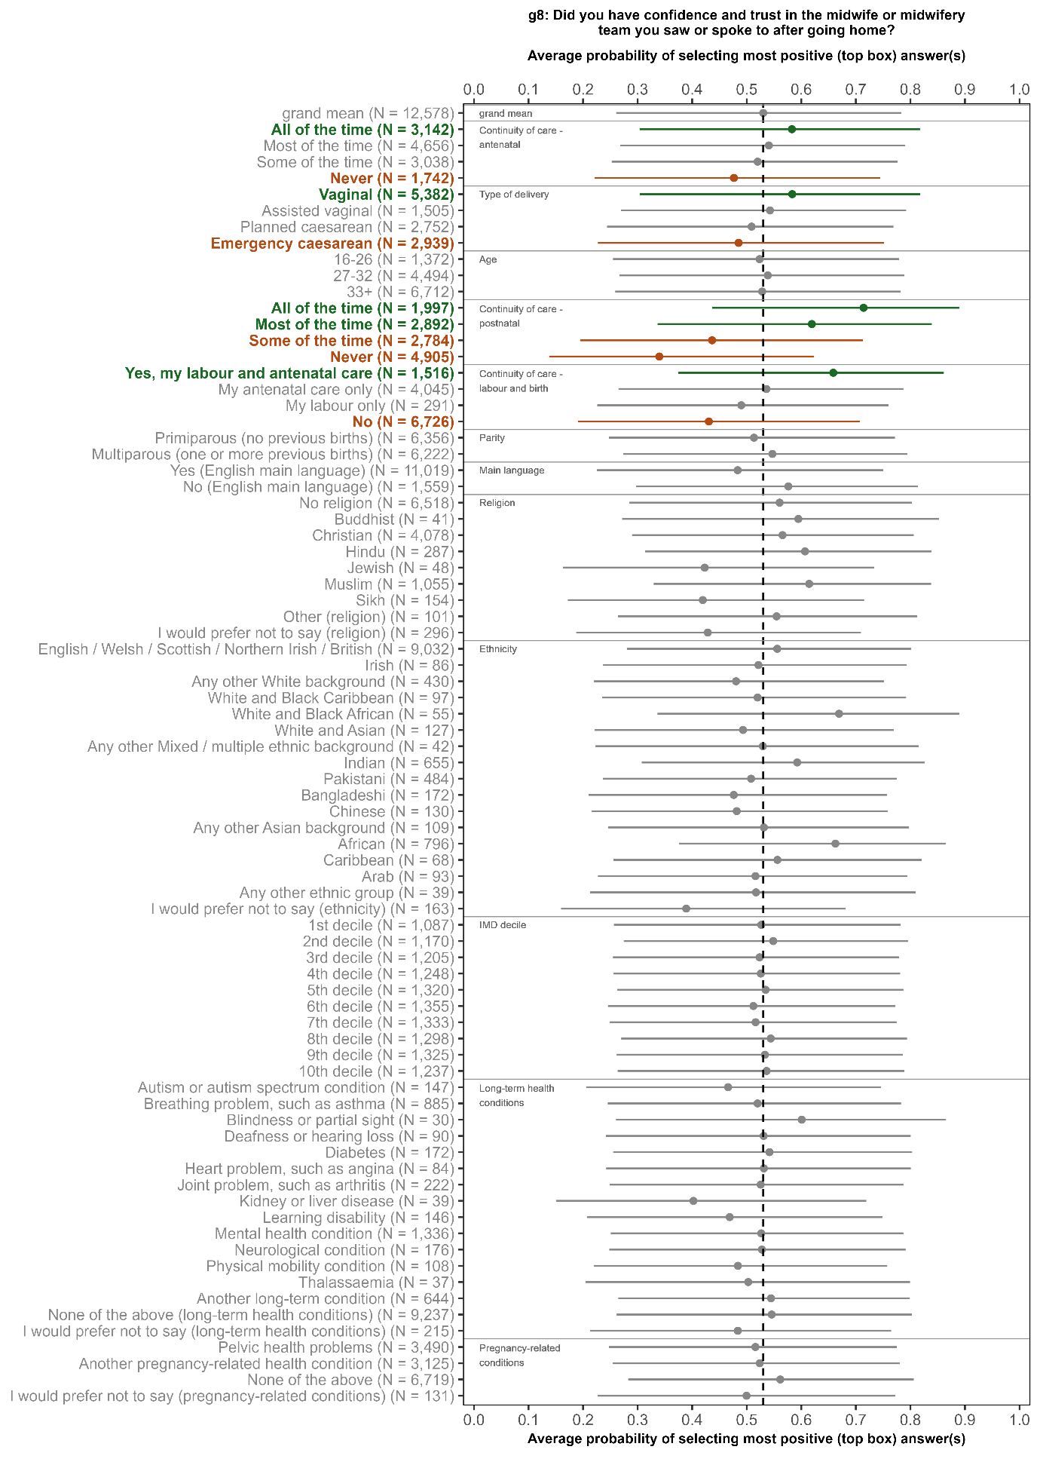

Sexual orientation and gender same as sex assigned at birth are not included in the charts shown in this appendix. This is because there were no statistically significant results for these characteristics for any of the questions analysed.

